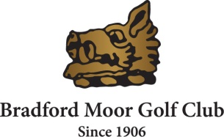
VENUE BOOKING ENQUIRY
Bradford Moor Golf Club info@bradfordmoorgolfclub.co.uk
Scarr Hall, Pollard Lane, Bradford. BD2 4RW Tel: 01274 771716

FUNCTION ROOM WITH FULLY LICENSED BAR AVAILABILITY
Contact Name
Contact Address
Contact telephone number
Date required
Type of event
Number of guests
Catering required (Y/N)
Start and finish times

Here at Bradford Moor we can offer a Function Room with a licensed Bar available, outside patio area and large car park and catering services.
The venue is available for Christenings, Birthdays, Anniversaries, Funerals and other social events.
All bookings are subject to approval by the club.
Please complete and return to the events coordinator at Bradford Moor Golf Club (or email info@bradfordmoorgolfclub.co.uk)

